LESSON DEVELOPMENT ONE

EFFECTS OF SOIL EROSION

STAGE/TIME | TEACHER’S ACTIVITIES | LEARNER'S ACTIVITIES – MIND/HANDS ON | LEARNING POINTS
Step 1  Introduction  (5 minutes) | Display fruit or food crops chart (sample, if available) for pupils to identify each of them.  Ask pupils to state their favorite fruits or foods and ask them some key questions –  Do you know where fruits and foods come from?  Do know where plant grows?  Do you know that in the future, we may not have any fruit and food crops if there soil is removed?  What removed the soil?  Teacher’s remark – one of the effects of erosion is it destroyed the soil nutrients and plants. | Yam, bean, orange, apple, rice, water melon, etc.  State their favorite fruits or foods and answers the questions asked.  Fruits and foods come from the plant.  Yes, on the soil – top soil.  Yes  Water, wind and tillage called erosion.  Listen to the teacher’s remark and lesson introduction. | Linking the Previous knowledge to the new lesson
Step 2  Development  (5 minutes)  Grouping | 1. Groups the learners into four groups – A, B, C, and D.  2. Guide the learners to choose a leader and secretary for your group.  3. Gives each group learning materials – Pictures or charts showing erosion. | 1. Belong to a group.  2. Choose their leader and secretary.  3. Received learning materials for their group. | Learner’s group, leader and secretary confirmed.
Step 3  Development  (10 minutes)  Step 4  Development  (5 minutes) | Guide and ask the groups to study and discuss of soil erosion on the chart.  Ask them to identify the kinds of erosion that causes the problems. | 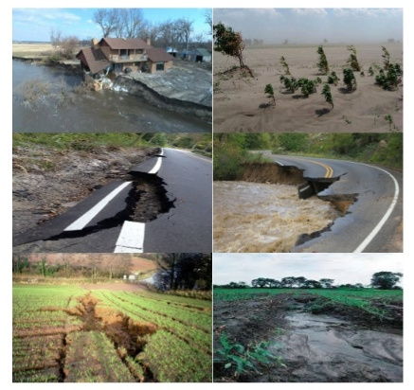 | Causes and Effects of Soil Erosion
 | Wrap up. | Groups discussion | Groups work
Step 5  Development  (5 minutes) | Asks each group to present their answers so that you can compare responses with those in other groups. | Presentation | Presentation
Step 6  Conclusion  (5 minutes) | To conclude the lesson, the teacher revises the entire lesson and ask the key questions. | The learners listen, ask and answer questions. | Lesson Evaluation and Conclusion

