LESSON DEVELOPMENT ONE

EARTH AND ITS MOVEMENTS – ROTATION AND REVOLUTION

STAGE/TIME | TEACHER’S ACTIVITIES | LEARNER'S ACTIVITIES – MIND/HANDS ON | LEARNING POINTS
Step 1  Introduction  (10 minutes) | Create a free place at the center of the class.  Ask the class captain to come at the center while others form a circle.  Give the captain a ball and ask him to roll the ball.  Then, guide and ask them to study and describe the position of the ball from the point of rolling.  Teacher’s remark – There are two basic movements of the earth – Rotation and revolution. | Clear the center of the class.  Pupils formed a circle as the class captain roll the ball.  As rotate (rolling), it moves around like a round.  Listen to the teacher’s remark and lesson introduction. | Linking the Previous knowledge to the new lesson
Step 2  Development  (5 minutes)  Grouping | 1. Groups the learners into four groups – A, B, C, and D.  2. Guide the learners to choose a leader and secretary for your group.  3. Gives each group learning materials – A globe, torch light, ball or spherical object. | 1. Belong to a group.  2. Choose their leader and secretary.  3. Received learning materials for their group. | Learner’s group, leader and secretary confirmed.
Step 3  Development  (5 minutes) | Look at the globe carefully. The globe represents the earth we lives.  Guide the pupils to identify areas covered by water and land, the seven continents and Nigeria in Africa continent. | 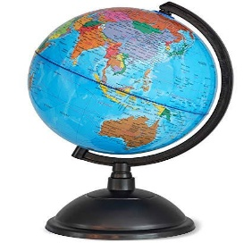  Follow the teacher’s lead and identify different parts of the world covered by water and land | Areas covered by water and land.
Step 4  Development  (10 minutes) | Guide the groups to demonstrate how earth’s rotation causes day and night.  Ask them to state 5 countries that received sunlight and their corresponding countries without sunlight. | Groups work | Effects of Earth’s rotation.
Step 5  Development  (5 minutes) | Asks each group to present their answers so that you can compare responses with those in other groups. | Presentation | Presentation
Step 6  Conclusion  (5 minutes) | To conclude the lesson, the teacher revises the entire lesson and ask the key questions.  SUMMARY  There are two earth’s movement – rotation and revolution. The earth rotate and revolve at the time.  Earth’s rotation is the movement of the earth around it in every 24 hours. This movement causes day and night.  Earth’s revolution is the movement of the earth around the sun in every 365 days (one year). This movement brings about different seasons at different places at different times and also causes defection of the water.  KEY QUESTIONS  State the different between earth’s rotation and revolution. | The learners listen, ask and answer questions. | Lesson Evaluation and Conclusion

