LESSON DEVELOPMENT TWO

THE SOLAR AND LUNAR ECLIPSE

STAGE/TIME | TEACHER’S ACTIVITIES | LEARNER'S ACTIVITIES – MIND/HANDS ON | LEARNING POINTS
Step 1  Introduction  (5 minutes) | Ask pupils to identify and describe the earth among the nine planets.  Teacher’s remark – as the earth’s rotate around its axis and revolve around the sun, the moon revolves around the earth – ECLIPSE | 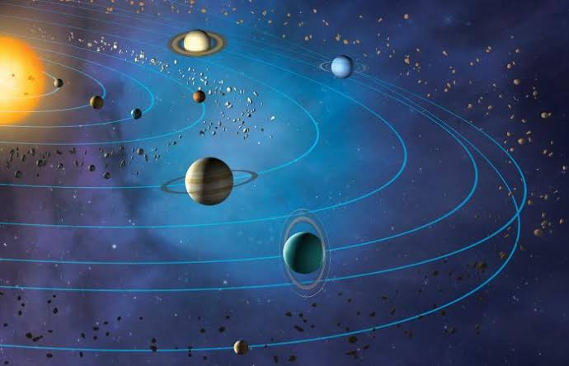  The earth is ours because it is where we live. The land, the mountains, the rivers and the seas are all parts of the earth. Plants and animals are also parts of the earth. The earth has one moon and many stars.  The earth’s rotate around its axis in every 24 hours, causing day and night and revolve around the sun in every 365 days in a year, causing different seasons  Listen to the teacher’s remark and lesson introduction. | Linking the Previous knowledge to the new lesson
Step 2  Development  (5 minutes)  Grouping | 1. Groups the learners into four groups – A, B, C, and D.  2. Guide the learners to choose a leader and secretary for your group.  3. Gives each group learning materials – Three different sizes of balls and charts showing the relationship between the sun and earth with the moon. | 1. Belong to a group.  2. Choose their leader and secretary.  3. Received learning materials for their group. | Learner’s group, leader and secretary confirmed.
Step 3  Development  (10 minutes) | Guide the pupils to study the chart careful, identify and differentiate between the two charts.  Lead to demonstrate the two types of eclipse and discuss their effects. | 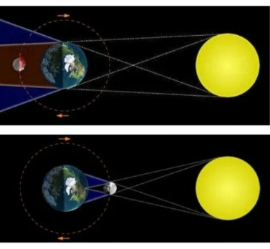  Demonstrating different types of eclipse and discuss their effects. | Solar and Lunar Eclipse
Step 4  Development  (5 minutes) | Wrap up | Groups work | Groups discussion
Step 5  Development  (5 minutes) | Asks each group to present their answers so that you can compare responses with those in other groups.  Call on one or two groups for presentation | Presentation | Presentation
Step 6  Conclusion  (10 minutes) | To conclude the lesson, the teacher revises the entire lesson and ask the key questions.  SUMMARY  Eclipses present the relationship between the sun and the earth with the moon.  There are types of eclipse – solar and lunar eclipse.  Solar eclipse is known as the eclipse of the sun. This is when the moon comes in between the sun and the earth.  Lunar eclipse is known as the eclipse of the moon. This occurs when the earth comes between the sun and the moon. | The learners listen, ask and answer questions. | Lesson Evaluation and Conclusion
