LESSON DEVELOPMENT THREE

COMPARE FRACTIONS USING <, =, >

STAGE/TIME | TEACHER’S ACTIVITIES | LEARNER'S ACTIVITIES – MIND/HANDS ON | LEARNING POINTS
Step 1  Introduction  (5 minutes) | Get a cardboard stripes and divide it into three parts (unequal). Guide and ask the pupils to identify each parts of the fractions.  Ask them to compare the space bars of A, B and C with one another using < or >. | A B C  Each of the fraction are 5/12, 3/12 and 4/12  A > B, C > B and A > C. | Linking the Previous knowledge to the new lesson
Step 2  Development  (5 minutes)  Grouping | 1. Groups the learners into four groups – A, B, C, and D.  2. Guide the learners to choose a leader and secretary for your group.  3. Gives each group learning materials – Cardboard or and fraction line or bar. | 1. Belong to a group.  2. Choose their leader and secretary.  3. Received learning materials for their group. | Learner’s group, leader and secretary confirmed.
Step 3  Development  (10 minutes) | Guide the pupils to study the charts carefully.  Help pupils to use the number line.  1. Which is greater, 1/3 or 1/4?  2. Which is greater, 1/6 or 5/6?  3. Which is smaller, 1/2or 1/3?  4. Which is smaller, 5/6 or 2/3? | 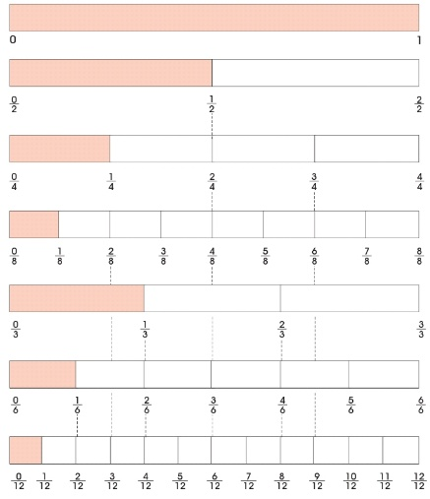  Follow the teacher’s instruction and use < or | Using < or >
Step 4  Development  (10 minutes) | Copy and complete. Use either <, > or =.  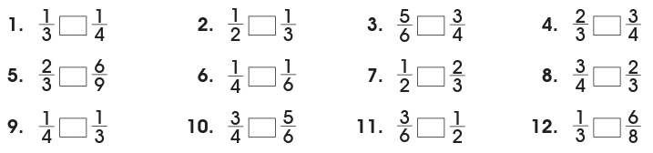 | Groups discussion | Groups work
Step 5  Development  (5 minutes) | Asks each group to present their answers so that you can compare responses with those in other groups.  Call two or more representatives for presentation. | Presentation | Presentation
Step 6  Conclusion  (5 minutes) | To conclude the lesson, the teacher revises the entire lesson and ask the key questions. | The learners listen, ask and answer questions. | Lesson Evaluation and Conclusion
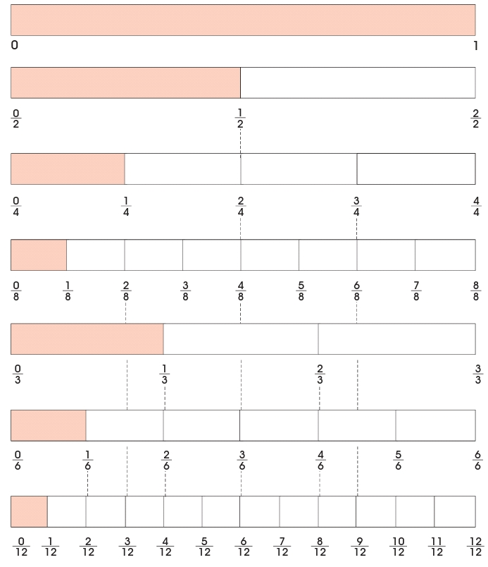
FRACTION LINES OR BARS

