LESSON DEVELOPMENT FOUR

ADDITION AND SUBTRACTION OF FRACTIONS WITH THE SAME DENOMINATORS

STAGE/TIME | TEACHER’S ACTIVITIES | LEARNER'S ACTIVITIES – MIND/HANDS ON | LEARNING POINTS
Step 1  Introduction  (5 minutes) | Ask pupils to perform basic addition on the following whole numbers –  5 + 7 =  8 + 6 =  3 + 9 =  Teacher’s remark – Just as we add one whole number to another, we can add fractions together as well. | Expected response  5 + 7 = 12  8 + 6 =14  3 + 9 =12  Listen to the teacher’s remark and lesson introduction. | Linking the Previous knowledge to the new lesson
Step 2  Development  (5 minutes)  Grouping | 1. Groups the learners into four groups – A, B, C, and D.  2. Guide the learners to choose a leader and secretary for your group.  3. Gives each group learning materials – | 1. Belong to a group.  2. Choose their leader and secretary.  3. Received learning materials for their group. | Learner’s group, leader and secretary confirmed.
Step 3 A  Development  (5 minutes) | Ask pupils to identify different parts of a fraction. The numerator, fraction bar and denominator. | 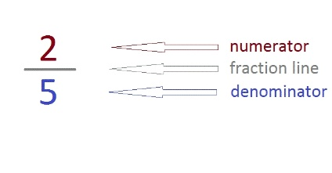 | Identification of fractional parts
Step 3 B  Development  (5 minutes) | Guide the pupils to add the numerators of all fractions with the same denominators –  Add  1. 2/7 and 3/7  2. 5/8 and 2/8 | 1/7 + 3/7  = (1 + 3)/7  = 4/7  5/8 + 2/8  = (5 + 2)/8  = 7/8 | Addition of fractions
Step 4  Development  (10 minutes) | 1. 5/11 + 4/11  2. 4/9 + 3/9  3. 5/12 + 1/12  4. 5/12 + 7/12 | Groups discussion | Groups work
Step 5  Development  (5 minutes) | Asks each group to present their answers so that you can compare responses with those in other groups.  Call two or more representatives for presentation. | Presentation | Presentation
Step 6  Conclusion  (5 minutes) | To conclude the lesson, the teacher revises the entire lesson and ask the key questions. | The learners listen, ask and answer questions. | Lesson Evaluation and Conclusion

