LESSON DEVELOPMENT TWO

CHARACTERISTICS OF LIVING AND NON LIVING THINGS

STAGE/TIME | TEACHER’S ACTIVITIES | LEARNER'S ACTIVITIES – MIND/HANDS ON | LEARNING POINTS
Step 1  Introduction  (5 minutes) | Get a doll of animal (or human) and a biscuit.  Call out any of the pupils to feed the doll with the biscuits.  Teacher’s remark – There are a lot of things that look like people, animals or things that are not living things. All non living things have the same characteristics whether looks like people, animals or plants. | 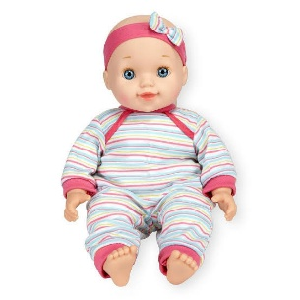  It is not a living things.  Listen to the teacher’s remark and lesson’s introduction – Characteristics of Living and Non Living Things | Linking the Previous knowledge to the new lesson
Step 2  Development  (5 minutes)  Grouping | 1. Groups the learners into four groups – A, B, C, and D.  2. Guide the learners to choose a leader and secretary for your group.  3. Gives each group learning materials – chart showing living and non living things. | 1. Belong to a group.  2. Choose their leader and secretary.  3. Received learning materials for their group. | Learner’s group, leader and secretary confirmed.
Step 3  Development  (10 minutes) | People, animals and plants depend on foods, water and air to be alive. Doll and other non living things do not.  Ask each group to state 10 characteristics of living and non living things. | Listen to the teacher’s comments and write 10 characteristics of living and non living things. | Characteristics of Living and non living things
Step 4  Development – Groups Work  (5 minutes) | Wrap up | Groups discussion | Groups work
Step 5  Development  (10 minutes) | Asks each group to present their answers so that you can compare responses with those in other groups.  Call out two or more groups for presentation. | Presentation | Presentation
Step 6  Conclusion  (5 minutes) | To conclude the lesson, the teacher revises the entire lesson and ask the key questions. | The learners listen, ask and answer questions. | Lesson Evaluation and Conclusion

