LESSON DEVELOPMENT ONE

LIVING AND NON LIVING THINGS

STAGE/TIME | TEACHER’S ACTIVITIES | LEARNER'S ACTIVITIES – MIND/HANDS ON | LEARNING POINTS
Step 1  Introduction  (5 minutes) | Ask pupils to identify each of the following things on the chart.  Teacher’s remark – There are living and non living things on the chart. | 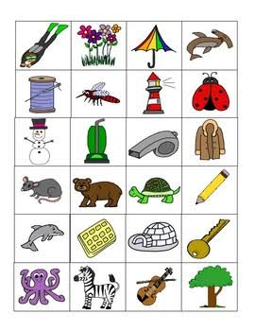  Listen to the teacher’s remark and lesson’s introduction – living and non living things. | Linking the Previous knowledge to the new lesson
Step 2  Development  (5 minutes)  Grouping | 1. Groups the learners into four groups – A, B, C, and D.  2. Guide the learners to choose a leader and secretary for your group.  3. Gives each group learning materials – chart showing living and non living things. | 1. Belong to a group.  2. Choose their leader and secretary.  3. Received learning materials for their group. | Learner’s group, leader and secretary confirmed.
Step 3  Development  (5 minutes) | Ask pupils to group all the things on the chart as living and non living things. | Living things Living non things | Living and non living things
Step 4  Development – Groups Work  (10 minutes) | Differentiate between living and non living things as shown on the charts. | Groups discussion | Groups work
Step 5  Development  (10 minutes) | Asks each group to present their answers so that you can compare responses with those in other groups. | Presentation | Presentation
Step 6  Conclusion  (5 minutes) | To conclude the lesson, the teacher revises the entire lesson and ask the key questions. | The learners listen, ask and answer questions. | Lesson Evaluation and Conclusion

