LESSON DEVELOPMENT TWO

DECIMAL FRACTIONS – HUNDREDTHS

STAGE/TIME | TEACHER’S ACTIVITIES | LEARNER'S ACTIVITIES – MIND/HANDS ON | LEARNING POINTS
Step 1  Introduction  (5 minutes) | Get 10 stripes of cardboard paper for the pupils to count.  Divide it into hundred parts and shade a part.  What is the fraction of the shaded stripes?  Teacher’s remark – Another way of writing 1/100 is 0.01. It is reads as “zero point zero one’. 1/100 is called fraction while 0.01 is called decimal fractions. | There are ten stripes of cardboard paper.  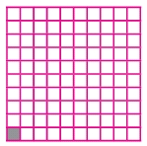  1 parts are shaded out of 100 equal parts. The fraction of shaded part = 1/100.  Listen to the teacher’s remark and lesson’s introduction – decimal fractions. | Linking the Previous knowledge to the new lesson
Step 2  Development  (5 minutes)  Grouping | 1. Groups the learners into four groups – A, B, C, and D.  2. Guide the learners to choose a leader and secretary for your group.  3. Gives each group learning materials – Cardboard stripes and chart showing the relationship between fractions and decimal fractions. | 1. Belong to a group.  2. Choose their leader and secretary.  3. Received learning materials for their group. | Learner’s group, leader and secretary confirmed.
Step 3  Development  (10 minutes) | Lead the pupils to understand that fractions with 100 as denominator are known as hundredth.  Guide the pupils to identify the fractional parts of the cardboard stripes. | Follow the teacher’s lead.  1 part out of 100 equal parts.  1/100 = 0.01, zero point zero one.  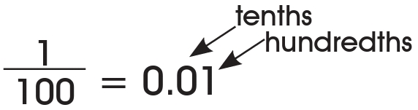  one – hundredth  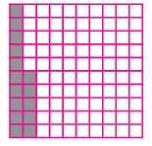  15 parts out of 100 equal parts.  15/100 = 0.15  Fifteen point one five.  Fifteen hundredths = One tenth five hundredths  That’s, 1 tenth 5 hundredths | Decimal fractions up to Hundredths
Step 4  Development – Groups Work  (10 minutes) | 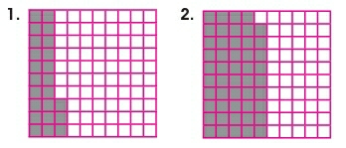  Write the following as decimals. Each large square is 1. | Groups discussion  1. 23/100 = 0.23, zero point two three  = 2/10 + 3/100  = 2 tenths 3 hundredths  Or 23th (Twenty three hundredth)  2. 59/100 = 0.59, zero point five nine.  = 5/10 + 9/100  = 5 tenths 9 hundredths  Or 59th (Fifty nine hundredths) | Groups work
Step 5  Development  (5 minutes) | Asks each group to present their answers so that you can compare responses with those in other groups.  Call out two or more groups for presentation. | Presentation | Presentation
Step 6  Conclusion  (5 minutes) | To conclude the lesson, the teacher revises the entire lesson and ask the key questions. | The learners listen, ask and answer questions. | Lesson Evaluation and Conclusion

