LESSON DEVELOPMENT ONE

DECIMAL FRACTIONS – TENTHS

STAGE/TIME | TEACHER’S ACTIVITIES | LEARNER'S ACTIVITIES – MIND/HANDS ON | LEARNING POINTS
Step 1  Introduction  (5 minutes) | Get 5 stripes of cardboard paper for the pupils to count.  Pick one of the stripes and divide it into ten parts and shade four parts.  What is the fraction of the shaded stripes?  Teacher’s remark – Another way of writing 4/10 is 0.4. It is reads as “zero point 4 four’. 4/10 is called fraction while 0.4 is called decimal fractions. | There are five stripes of cardboard paper.  4 parts are shaded out of 10 equal parts. The fraction of shaded part = 4/10  Listen to the teacher’s remark and lesson’s introduction – decimal fractions. | Linking the Previous knowledge to the new lesson
Step 2  Development  (5 minutes)  Grouping | 1. Groups the learners into four groups – A, B, C, and D.  2. Guide the learners to choose a leader and secretary for your group.  3. Gives each group learning materials – Cardboard stripes and chart showing the relationship between fractions and decimal fractions. | 1. Belong to a group.  2. Choose their leader and secretary.  3. Received learning materials for their group. | Learner’s group, leader and secretary confirmed.
Step 3  Development  (10 minutes) | Ask pupils to study the charts carefully and guide them to read the corresponding fractions.  Lead the pupils to understand that fractions with 10 as denominator are known as tenths. That’s nine-tenths.  Guide the pupils to identify the fractional parts of the following cardboard stripes.  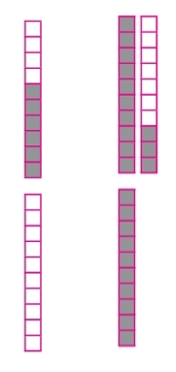 | 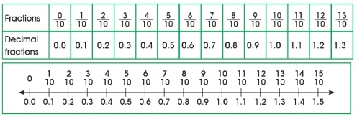  1/10 = 0.1 and read as zero point one. 11/10 = 1.1 and read as one point one.  Follow the teacher’s lead.  6/10 = 0.6  Zero point six  Six – tenth.  13/10 = 1 + 3/10  = 1.3  One point three  One and three – tenth  0/10 = 0.0  Zero point zero  Zero – tenths = zero  10/10 = 1.0  One point zero | Relationship between fractions and decimal fractions.
Step 4  Development – Groups Work  (10 minutes) | Write each of the following fractions as a decimal.  1. 3/10  2. 77/10  Write each of the following as a decimal and common fractions.  3. Four three-tenths  4. Eleven seven-tenths  5. 6 tens, 4 units and 9 tenths | Groups discussion  1. 0.3  2. 7 + 7/10 = 7.7  3. 4 + 3/10 = 4.3  4. 11 + 7/10 = 11.7  5. 6 x 10 + 4 + 9/10 = 60 + 4 + 9/10  = 64 9/10 = 64.9 | Groups work
Step 5  Development  (5 minutes) | Asks each group to present their answers so that you can compare responses with those in other groups.  Call out two or more groups for presentation. | Presentation | Presentation
Step 6  Conclusion  (5 minutes) | To conclude the lesson, the teacher revises the entire lesson and ask the key questions. | The learners listen, ask and answer questions. | Lesson Evaluation and Conclusion

