LESSON DEVELOPMENT TWO

EXPRESS A NUMBER AS A PERCENTAGE OF ANOTHER NUMBER

STAGE/TIME | TEACHER’S ACTIVITIES | LEARNER'S ACTIVITIES – MIND/HANDS ON | LEARNING POINTS
Step 1  Introduction  (5 minutes) | Ask pupils – what is the shaded part of the square?  Teacher’s remark – The shaded part of the square is 27/100.That is 27 out of 100 (denominator is 100)  A fraction whose denominator is 100 is known as a percentage.  Another way of describing this part of a whole is to say 27% of the circle is shaded.10% means 27 out of 100 (we say 27 percent).  Today, we are going to be express a number as percentage of another number. | 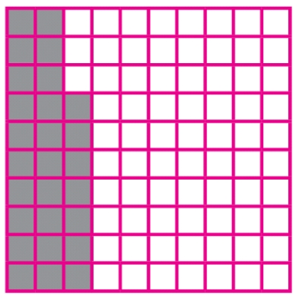  The shaded parts of the square is 27/100.  Listen to the teacher’s remark and lesson’s introduction – Express a number as a percentage of another number. | Linking the Previous knowledge to the new lesson
Step 2  Development  (5 minutes)  Grouping | 1. Groups the learners into four groups – A, B, C, and D.  2. Guide the learners to choose a leader and secretary for your group.  3. Gives each group learning materials – NMM Book 6. | 1. Belong to a group.  2. Choose their leader and secretary.  3. Received learning materials for their group. | Learner’s group, leader and secretary confirmed.
Step 3 A  Development  (5 minutes) | To write a number or quantity as a percentage of another –  1. write the first number or quantity as a fraction of the second .  2. multiply the fraction by 100.  Guide the pupils to express a number or quantity as a percentage of another number.  Michael scored 36 marks out of 60. Express the marks in percentage. | Listen to the teacher’s explanation and follow his/her instructions.  Michael scored 36 marks out of 60.  Marks scored – 36  Total marks – 60  Ratio – 36 : 60  Fraction – 36/60  Percentage – 36/60 x 100  = (36 x 100)/60  =. 3 600/60  = 60% | Percentage of two numbers.
Step 3 B  Development  (5 minutes) | Guide the pupils to find 12% of 60.  Teacher’s remark – The result is 20 not 20%. | Follow the teacher’s instructions and attempt the given question.  12% of 60  = (12 x 100)/60  = 1 200/60  = 20.  Listen to the teacher’s remark. | Subtraction of Fractions
Step 4  Development – Individual/Groups Work  (10 minutes) | Guide the pupils to attempt the questions –  40% of a village school population were girls.  What per cent were boys?  If there were 250 pupils, how many were girls? | Groups discussion | Groups work
Step 5  Development  (5 minutes) | Asks each group to present their answers so that you can compare responses with those in other groups.  Call out two or more groups for presentation. | Presentation | Presentation
Step 6  Conclusion  (5 minutes) | To conclude the lesson, the teacher revises the entire lesson and ask the key questions. | The learners listen, ask and answer questions. | Lesson Evaluation and Conclusion

