LESSON DEVELOPMENT ONE

INTRODUCTION TO MEASUREMENT

STAGE/TIME | TEACHER’S ACTIVITIES | LEARNER'S ACTIVITIES – MIND/HANDS ON | LEARNING POINTS
Step 1  Introduction  (5 minutes) | Present basic measuring tools for pupils to identify each and guide them state its uses.  Teacher’s remark – There are different measuring tools used for measurement. | 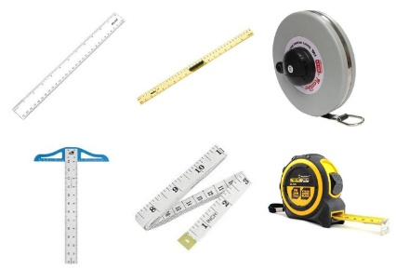  Ruler, board ruler, measuring tapes and T – square.  They are all used for measurement. Ruler and board ruler are used for drawing lines and measuring lengths.  Measuring tapes are used for measuring a longer length while T – square is used for technical drawings and guide for drawing.  Listen to the teacher’s remark and lesson’s introduction – Measurement. | Linking the Previous knowledge to the new lesson
Step 2  Development  (5 minutes)  Grouping | 1. Groups the learners into four groups – A, B, C, and D.  2. Guide the learners to choose a leader and secretary for your group.  3. Gives each group learning materials – basic measuring tools. | 1. Belong to a group.  2. Choose their leader and secretary.  3. Received learning materials for their group. | Learner’s group, leader and secretary confirmed.
Step 3 A  Development  (5 minutes) | Ask pupils to mention other things that can be use for measurement without using measuring tools. | Hand, arms (one or the two arms), Legs, A straight object, Book, Biro, Pencils, etc. | Other things used for measuring.
Step 3 B  Development  (10 minutes) | Guide the groups to used their hand to measure the four sides and height of their desk, arms to measure the four walls of their classroom.  Ask them to define measurement. | Group work  Measurement is the action of measuring something. | Measuring side and height.  Meaning of measurement
Step 4  Development – Individual/Groups Work  (5 minutes) | Wrap up | Groups discussion | Groups work
Step 5  Development  (5 minutes) | Asks each group to present their answers so that you can compare responses with those in other groups.  Call out two or more groups for presentation. | Presentation | Presentation
Step 6  Conclusion  (5 minutes) | To conclude the lesson, the teacher revises the entire lesson and ask the key questions. | The learners listen, ask and answer questions. | Lesson Evaluation and Conclusion

