LESSON DEVELOPMENT TWO

MEASUREMENT OF LENGTH AND BREADTH

STAGE/TIME | TEACHER’S ACTIVITIES | LEARNER'S ACTIVITIES – MIND/HANDS ON | LEARNING POINTS
Step 1  Introduction  (5 minutes) | Guide the pupils to draw four sided shape – rectangular shape.  Ask the pupils to mention objects that have rectangular shapes and state the number of sides that all these shapes have.  Trace all the four sides and ask pupils to compare one with another and comment on them.  Teacher’s remark – The four sides are grouped into two part and each is called a length or breadth. | Textbook, exercise book, board, classroom wall or floor, football field, etc.  Two opposite sides are equal.  Listen to the teacher’s remark and lesson’s introduction – length and breath. | Linking the Previous knowledge to the new lesson
Step 2  Development  (5 minutes)  Grouping | 1. Groups the learners into four groups – A, B, C, and D.  2. Guide the learners to choose a leader and secretary for your group.  3. Gives each group learning materials – basic measuring tools – ruler, board ruler and measuring tape. | 1. Belong to a group.  2. Choose their leader and secretary.  3. Received learning materials for their group. | Learner’s group, leader and secretary confirmed.
Step 3 A  Development  (5 minutes) | Guide the pupils to identify the unit of measurement for ruler, board ruler and measuring tape. | Ruler and board ruler – centimeter (cm) and inch.  Measuring tape – centimeter (cm), inch and feet (ft). | Standard unit for measuring length and breadth
Step 3 B  Development  (5 minutes) | Let each group study the measuring tools calibration – ruler, board ruler and measuring tape.  Discuss with the groups, the calibrates of each measuring tools – ruler, board ruler and measuring tape. | 0.1 cm, 0.2m, 0.3m, 0.4m, 0.5m, 0.6m, 0.7m, 0.8m, 0.9m, 1m, 1.1m, etc.  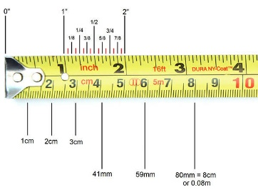 | Taking measuremen reading
Step 4  Development – Individual/Groups Work  (10 minutes) | Measure the length and breadth of their textbook and of the flat surface of teacher’s table. | Groups discussion | Groups work
Step 5  Development  (5 minutes) | Asks each group to present their answers so that you can compare responses with those in other groups.  Call out two or more groups for presentation. | Presentation | Presentation
Step 6  Conclusion  (5 minutes) | To conclude the lesson, the teacher revises the entire lesson and ask the key questions. | The learners listen, ask and answer questions. | Lesson Evaluation and Conclusion

