LESSON DEVELOPMENT THREE

AREA OF OBJECTS

STAGE/TIME | TEACHER’S ACTIVITIES | LEARNER'S ACTIVITIES – MIND/HANDS ON | LEARNING POINTS
Step 1  Introduction  (5 minutes) | Ask pupils to identify the length and breath of the shape.  Square the shape and guide the pupils to identify the length and breath in cm.  Ask them to multiple the length and breath together and also, count the number of squares.  Then, ask the pupils to compare the results together.  Teacher’s remark – Length multiple by the breadth is call a area. | 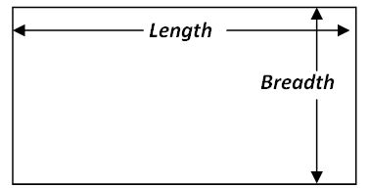  1 2 3 4 5 6  2  3  Length – 6 cm  Breadth – 3 cm  Length x breath  = 6 cm x 3 cm  = 18 cm^2  1 2 3 4 5 6  7 8 9 10 11 12  13 14 15 16 17 18  Length x breath, the result is the same with the total number of squares on the chart.  Listen to the teacher’s remark and lesson’s introduction – Area. | Linking the Previous knowledge to the new lesson
Step 2  Development  (5 minutes)  Grouping | 1. Groups the learners into four groups – A, B, C, and D.  2. Guide the learners to choose a leader and secretary for your group.  3. Gives each group learning materials – basic measuring tools – measuring tools and shapes or objects. | 1. Belong to a group.  2. Choose their leader and secretary.  3. Received learning materials for their group. | Learner’s group, leader and secretary confirmed.
Step 3 A  Development  (10 minutes) | Ask the groups to measure the following shapes. |  | Measurement of Shapes
Step 3 B  Development  (5 minutes) | Ask the groups to find the area of the shapes measured. | Work in progress | Area of Objects
Step 4  Development – Individual/Groups Work  (5 minutes) | Wrap up | Groups discussion | Groups work
Step 5  Development  (5 minutes) | Asks each group to present their answers so that you can compare responses with those in other groups.  Call out two or more groups for presentation. | Presentation | Presentation
Step 6  Conclusion  (5 minutes) | To conclude the lesson, the teacher revises the entire lesson and ask the key questions. | The learners listen, ask and answer questions. | Lesson Evaluation and Conclusion

