LESSON DEVELOPMENT ONE

GROWING CROPS WITH COMPOST AND FERTILIZER

STAGE/TIME | TEACHER’S ACTIVITIES | LEARNER'S ACTIVITIES – MIND/HANDS ON | LEARNING POINTS
Step 1  Introduction  (5 minutes) | There are three types of soil, name them.  Ask pupils, which of the soil is good for growing crops?  Discuss with the pupils meaning of growing crops.  Teacher’s remark – Growing crops require a lot of effort and patience. The effort won’t worth it if the crops grown do not produce a better crops. | Sandy, clay and loamy soil.  Loamy soil.  Take active in class discussion – Growing crops include loosening the soil, planting, special watering, moving plants when they grow bigger, and harvesting, among others.  Listen to the teacher’s remark and lesson’s introduction – Growing in with Compost and Fertilizers. | Linking the Previous knowledge to the new lesson
Step 2  Development  (5 minutes)  Grouping | 1. Groups the learners into four groups – A, B, C, and D.  2. Guide the learners to choose a leader and secretary for your group.  3. Gives each group learning materials – compost and fertilizer. | 1. Belong to a group.  2. Choose their leader and secretary.  3. Received learning materials for their group. | Learner’s group, leader and secretary confirmed.
Step 3  Development  (5 minutes) | Crops grown well and produced high yield, if the soil is rich in nutrients. Soil nutrients are essential elements that make crops to grow well.  Ask the groups, What happened to crops if the soil is not rich in nutrients?  How can a soil can be enrich with adequate nutrients?  Ask pupils to describe a fertilizer. | Listen to the teacher’s explanation.  The crop will not grow well and produce better a crop.  We can add fertilizer to enrich the soil.  A fertilizer is any material added to the soil to increase its nutrients level. | Fertilizer
Step 4  Development  (10 minutes) | There are two types of fertilizer – organic and chemical fertilizer.  Ask the groups to differentiate organic and chemical fertilizers as shown on the chart or given sample.  Note – monitor the pupils in dealing with chemical fertilizer if available. | Groups work.  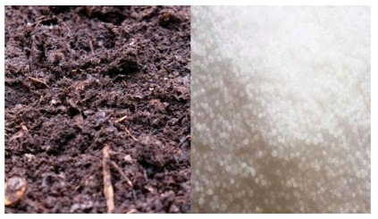 | Groups Evaluation
Step 5  Development  (10 minutes) | Asks each group to present their answers so that you can compare responses with those of other groups.  Call on two or representatives for presentation. | Presentation | Presentation
Step 6  Conclusion  (5 minutes) | To conclude the lesson, the teacher revises the entire lesson and ask the key questions.  SUMMARY – Growing crops include loosening the soil, planting, special watering, moving plants when they grow bigger, and harvesting, among others.  A fertilizer is any material added to the soil to increase its nutrients level.  Types of Fertilizer  Organic fertilizers are made from living things like plants and animals and they are called manure.  Chemical fertilizers are made from non living things like plants and animals. It contains the elements that plants need for healthy growth. These elements are N – nitrogen, P – phosphorus and K – potassium and called NPK Fertilizers. | The learners listen, ask and answer questions. | Lesson Evaluation and Conclusion

