LESSON DEVELOPMENT THREE

IMPROVISING MEASURING CYLINDER

STAGE/TIME | TEACHER’S ACTIVITIES | LEARNER'S ACTIVITIES – MIND/HANDS ON | LEARNING POINTS
Step 1  Introduction  (5 minutes) | Let the pupils fill the two cups with water and find the volume of liquid in the cups.  Why is one of the cups cannot be known?  Teacher’s remark – Tell the pupils that today they are going to make their own measuring cylinders; the bottle will contain the liquid and the paper strip will have the scale. | 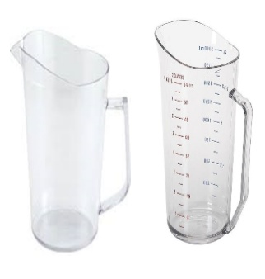  The volume of liquid in the first cup is unknown while the second cup is ____.  Because it is not graduated measuring cup.  Listen to the teacher’s remark and lesson’s introduction – Improvising Measuring Cylinders. | Linking the Previous knowledge to the new lesson
Step 2  Development - Whole class  (5 minutes)  Grouping | 1. Groups the learners into four groups – A, B, C, and D.  2. Guide the learners to choose a leader and secretary for your group.  3. Gives each group learning materials – Strips of paper, pencils, water, cello tape, empty water bottles (750ml or 75cl), large container for water, and a measuring jug that is marked in ml. | 1. Belong to a group.  2. Choose their leader and secretary.  3. Received learning materials for their group. | Learner’s group, leader and secretary confirmed.
Step 3 A  Development  (10 minutes) | Guide the groups to make a paper strip with marked in ml.  Ask them to stuck the strip of paper onto the bottle. Fill the bottle with water, take the reading and record your measurement. | Follow the teacher’s lead and make a paper strip marked in ml.  Stuck the paper strip on the bottle. Use the bottle to take and record the measurement of liquid in another container.  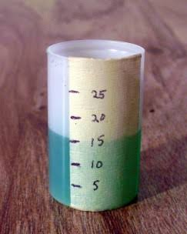 | Paper strip marked in ml.
Step 4  Development  (5 minutes) | Wrap up | Groups discussion | Groups work
Step 5  Development  (5 minutes) | Asks each group to present their answers so that you can compare responses with those in other groups.  Call out two or more groups for presentation. | Presentation | Presentation
Step 6  Conclusion  (5 minutes) | To conclude the lesson, the teacher revises the entire lesson and ask the key questions. | The learners listen, ask and answer questions. | Lesson Evaluation and Conclusion

