LESSON DEVELOPMENT TWO

MEASURING THE VOLUME OF LIQUIDS

STAGE/TIME | TEACHER’S ACTIVITIES | LEARNER'S ACTIVITIES – MIND/HANDS ON | LEARNING POINTS
Step 1  Introduction  (5 minutes) | Ask the pupils which of the three containers can contain most or least amount of water. And how least container can fill the most.  Teacher’s remark - Tell pupils that we will be learning to measure liquids accurately in today’s lesson. | 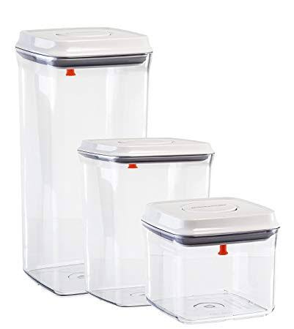  Listen to the teacher’s remark and lesson’s introduction – Measuring the Volume of Liquid. | Linking the Previous knowledge to the new lesson
Step 2  Development - Whole class  (5 minutes)  Grouping | 1. Groups the learners into four groups – A, B, C, and D.  2. Guide the learners to choose a leader and secretary for your group.  3. Gives each group learning materials – ml, cl and l. | 1. Belong to a group.  2. Choose their leader and secretary.  3. Received learning materials for their group. | Learner’s group, leader and secretary confirmed.
Step 3 A  Development  (10 minutes) | Ask pupils to state the metric units of volume.  Discuss with the groups, the units of the following containers – Pepsi or coke in Cl and L.  Discuss with them, the relationship between these units of volume using Ml, Cl and L containers, asking the pupils to fill the 50 cl pepsi water and find out how many cl can fill a litre. | Ml – Millimeter  Cl – Centimeter  L – Litre  50 cl and one litre.  Participate in the class discussion.  Two 50 cl pepsi can fill a litre pepsi. | Measuring in centimeter and litre.
Step 4  Development – Individual/Groups Work  (5 minutes) | Ask the groups to use measuring cylinder to measure the volume of liquid in the containers. | Groups discussion  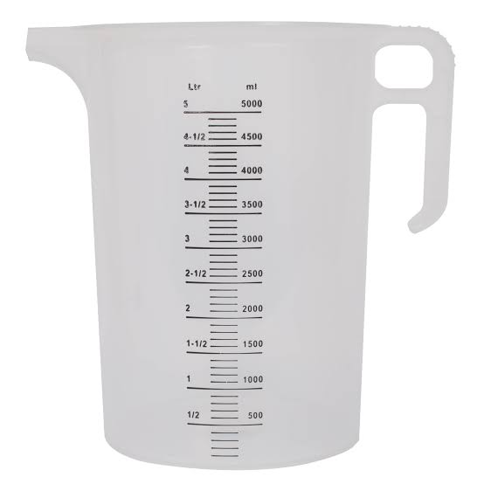 | Groups work – Measuring the volume of liquid in the container.
Step 5  Development  (5 minutes) | Asks each group to present their answers so that you can compare responses with those in other groups.  Call out two or more groups for presentation. | Presentation | Presentation
Step 6  Conclusion  (5 minutes) | To conclude the lesson, the teacher revises the entire lesson and ask the key questions. | The learners listen, ask and answer questions. | Lesson Evaluation and Conclusion

