LESSON DEVELOPMENT TWO

TYPES OF WASTE

STAGE/TIME | TEACHER’S ACTIVITIES | LEARNER'S ACTIVITIES – MIND/HANDS ON | LEARNING POINTS
Step 1  Introduction  (5 minutes) | Ask each pupil to choose a partner and discuss the different kinds of things they throw away as waste in their homes.  Ask each pair to mention two or waste product they discussed.  Write their answers on the board.  Teacher’s remark – Tell pupils that they are going to learn about why different kinds of waste are unhealthy in today’s lesson. | Food leftovers, furniture, cutlery, broken plates, broken bottles, spoilt milk, water from wash plates or clothes.  Listen to the teacher’s remark and lesson’s introduction – Types of Waste. | Linking the Previous knowledge to the new lesson
Step 2  Development - Whole class  (5 minutes)  Grouping | 1. Groups the learners into four groups – A, B, C, and D.  2. Guide the learners to choose a leader and secretary for your group.  3. Gives each group learning materials – solid and liquid waste materials. | 1. Belong to a group.  2. Choose their leader and secretary.  3. Received learning materials for their group. | Learner’s group, leader and secretary confirmed.
Step 3 A  Development  (10 minutes) | Ask pupils to work with their teams and sort out the different waste materials on their list into liquid and solid waste.  Ask the pupils to discuss why some wastes have to go into the dustbin while we can pour others down the sink?  Draw the following table on the board for pupils to complete. | Cannot go down the sink because they are too big and will block the sink, liquid cannot go into the dustbin because it will come out, etc.).  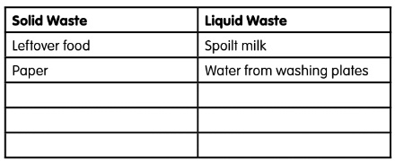
Step 3 B  Development  (5 minutes) | Differentiate between solid and liquid waste. | Solid waste refers to any garbage, refuse or rubbish that we generate in our homes, and other places which can be thrown into a dustbin or refuse dump, e.g., empty packets, spoilt food items, broken furniture, etc.  Waste refers to all waste that we generate in our homes and other places which come in liquid form and cannot be thrown into the dustbin e.g., spoilt milk, leftover drinks, washing water, etc. | Types of Waste
Step 4  Development  (5 minutes) | Wrap up | Groups discussion | Groups work
Step 5  Development  (5 minutes) | Asks each group to present their answers so that you can compare responses with those in other groups.  Call out two or more groups for presentation. | Presentation | Presentation
Step 6  Conclusion  (5 minutes) | To conclude the lesson, the teacher revises the entire lesson and ask the key questions. | The learners listen, ask and answer questions. | Lesson Evaluation and Conclusion

