LESSON DEVELOPMENT TWO

IMPORTANCE OF INCREASED LABOUR ON CROPS YIELD

STAGE/TIME | TEACHER’S ACTIVITIES | LEARNER'S ACTIVITIES – MIND/HANDS ON | LEARNING POINTS
Step 1  Introduction  (5 minutes) | Take the pupils outside the class to a grass area within the school.  Land clearing is the first step in planting of crops.  Group the all class into two groups (90% to 10%) to clear the same portion and observe the group’s reaction.  Ask them, why are they complaining.  Teacher’s remark – If small size families cultivate land for farming, they are likely to have small farm lands than the big family size. The same goes with the two groups. Today’s lesson, we are going to discuss importance of Increased labour on crops yield. | Follow the teacher’s lead.  Listen to the teacher’s explanation.  The groups with less member will complain much.  The work is too much, we won’t want to finish in time.  Listen to the teacher’s explanation and lesson’s introduction – Importance of Increased Labour on Crops Yield. | Linking the Previous knowledge to the new lesson
Step 2  Development - Whole class  (5 minutes)  Grouping | 1. Groups the learners into four groups – A, B, C, and D.  2. Guide the learners to choose a leader and secretary for your group.  3. Gives each group learning materials – chart showing family on farmland. | 1. Belong to a group.  2. Choose their leader and secretary.  3. Received learning materials for their group. | Learner’s group, leader and secretary confirmed.
Step 3  Development  (10 minutes) | Ask the groups to write 10 professions they know.  Probably, some or none will mention being a farmer. Tell the pupils that there is need for more labour on farmland.  Discuss with the groups the importance of increased labour on crops yield. | Doctor, lawyer, engineering, banker, accountant, teacher, etc.  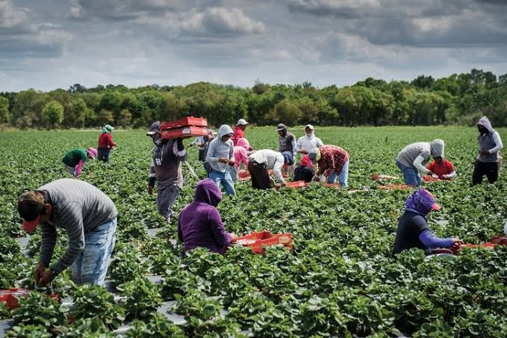  Participate in the class discussion. | List of Professions
Step 4  Development  (10 minutes) | Ask the groups to write 5 importance of increased in labour on crops yield. | Groups discussion | Groups work
Step 5  Development  (5 minutes) | Asks each group to present their answers so that you can compare responses with those in other groups.  Call out two or more groups for presentation. | Presentation | Presentation
Step 6  Conclusion  (5 minutes) | To conclude the lesson, the teacher revises the entire lesson and ask the key questions.  SUMMARY  IMPORTANCE OF INCREASED IN LABOUR ON CROPS YIELD  Large family size means large amount of food to feed the members. A small amount of food but they produce less.  1. More people to work on the farm.  2. More crops will be produced.  3. More income from the sales of farm produce. | The learners listen, ask and answer questions. | Lesson Evaluation and Conclusion

