LESSON DEVELOPMENT ONE

SQUARE ROOT OF WHOLE NUMBERS

STAGE/TIME | TEACHER’S ACTIVITIES | LEARNER'S ACTIVITIES – MIND/HANDS ON | LEARNING POINTS
Step 1  Introduction  (5 minutes) | Ask pupils to find the square of the following numbers – 4 and 5.  Find the square root of the following numbers – 9 and 25.  Teacher’s remark – In today’s lesson, we are going to be add and subtract square or square root of whole numbers. | 4^2 = 4 x 4 = 8  5^2 = 5 x 5 = 25  √9 = √(3 x 3) = 3  √25 = √(5 x 5) = 5  Listen to the teacher’s remark and lesson’s introduction – Addition and Subtraction of Square and Square Root of Whole Numbers. | Linking the Previous knowledge to the new lesson
Step 2  Development  (5 minutes)  Grouping | 1. Groups the learners into four groups – A, B, C, and D.  2. Guide the learners to choose a leader and secretary for your group.  3. Gives each group learning materials – square and square roots chart. | 1. Belong to a group.  2. Choose their leader and secretary.  3. Received learning materials for their group. | Learner’s group, leader and secretary confirmed.
Step 3  Development  (15 minutes) | Guide the pupils to use the chart to find the value of the following.  1. 4^2 + √9  2. √25 + 8^2  3. √81 + √100  4. 8^2 + √64 | 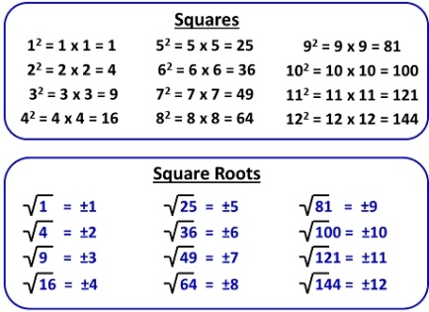  4^2 + √9  = 16 + 9  = 25 | Addition and Subtraction of Square and Square Root of Whole Numbers
Step 4  Development  (5 minutes) | Wrap up. | Groups work. | Groups Evaluation
Step 5  Development  (5 minutes) | Asks each group to present their answers so that you can compare responses with those of other groups.  Call on one or two groups for presentation. | Presentation | Presentation
Step 6  Conclusion  (5 minutes) | To conclude the lesson, the teacher revises the entire lesson and ask the key questions. | The learners listen, ask and answer questions. | Lesson Conclusion

