LESSON DEVELOPMENT ONE

SQUARE OF WHOLE NUMBERS

STAGE/TIME | TEACHER’S ACTIVITIES | LEARNER'S ACTIVITIES – MIND/HANDS ON | LEARNING POINTS
Step 1  Introduction  (5 minutes) | Ask pupils to multiply the following numbers by itself – 1, 2, 3, 4, 5, 6, 7, 8, 9 and 10.  Teacher’s remark – 1 x 1 is written as 1^2 = 4 , 2 x 2 is written as 2^2 = 4. This called square of a number. | 1 x 1 = 1  2 x 2 = 4  3 x 3 = 9  4 x 4 = 16,….  Listen to the teacher’s remark and lesson’s introduction – Square of Whole Numbers Up to 50. | Linking the Previous knowledge to the new lesson
Step 2  Development  (5 minutes)  Grouping | 1. Groups the learners into four groups – A, B, C, and D.  2. Guide the learners to choose a leader and secretary for your group.  3. Gives each group learning materials – square chart. | 1. Belong to a group.  2. Choose their leader and secretary.  3. Received learning materials for their group. | Learner’s group, leader and secretary confirmed.
Step 3  Development  (5 minutes) | Guide the pupils to write the numbers 3 – 20 as the square itself. | 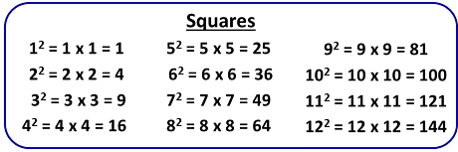 | Writing a number a square of itself.
Step 4  Development  (15 minutes) | Guide the groups to the square of the following numbers – 11, 15, 23 and 51. | 1. 11^2 = 11 x 11  T U  1 1  x 1 1  1 1  + 1 1  1 2 1 | Evaluation
Step 4  Development  (5 minutes) | Wrap up. | Groups work. | Groups Evaluation
Step 5  Development  (5 minutes) | Asks each group to present their answers so that you can compare responses with those of other groups.  Call on one or two groups for presentation. | Presentation | Presentation
Step 6  Conclusion  (5 minutes) | To conclude the lesson, the teacher revises the entire lesson and ask the key questions. | The learners listen, ask and answer questions. | Lesson Conclusion

