LESSON DEVELOPMENT TWO

EXAMINING BLOOD VESSELS

STAGE/TIME | TEACHER’S ACTIVITIES | LEARNER'S ACTIVITIES – MIND/HANDS ON | LEARNING POINTS
Step 1  Introduction  (5 minutes) | You are always advised not to play with sharp objects like blades, knives, needles, etc. True/False  What happens when you play with such object?  When it cuts, what comes out?  Blood is very important in the blood that’s why you are warned not to play with sharp objects. This is because blood is life.  What other things has blood? Name them.  Teacher’s remark – The blood in the blood are in the vessels called blood vessels. | True  It cuts.  Blood  Listen to the teacher’s comments.  Animals have blood – chicken, goat, cow, etc.  Listen to the teacher’s remark and lesson’s introduction – Blood Vessels. | Linking the Previous knowledge to the new lesson
Step 2  Development  (5 minutes)  Grouping | 1. Groups the learners into four groups – A, B, C, and D.  2. Guide the learners to choose a leader and secretary for your group.  3. Gives each group learning materials – chart or model of the blood vessels. | 1. Belong to a group.  2. Choose their leader and secretary.  3. Received learning materials for their group. | Learner’s group, leader and secretary confirmed.
Step 3  Development  (10 minutes) | Present the model or chart of the blood vessels to the pupils.  Guide them to identify the different parts of the blood vessels. | 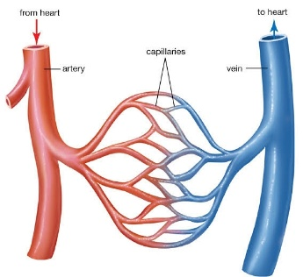 | The Blood Vessels
Step 4  Development  (10 minutes) | Ask each pupil the group to draw and label the heart.  Describe and choose one or two for presentation. | TYPES OF BLOOD VESSELS  There are three main types of blood vessels –  Artery – It moves blood from the heart to the tissues of the body.  Vein – It moves blood from tissues of the body to the heart.  Capillary – It connects the flow of blood between Artery and Vein. | Groups Evaluation
Step 5  Development  (5 minutes) | Asks each group to present their answers so that you can compare responses with those of other groups.  Call on one or two groups for presentation. | Presentation | Presentation
Step 6  Conclusion  (5 minutes) | To conclude the lesson, the teacher revises the entire lesson and ask the key questions.  THE BLOOD VESSELS  The blood vessels are the vessels that move blood from the heart to the heart throughout human body. | The learners listen, ask and answer questions. | Lesson Conclusion

