LESSON DEVELOPMENT ONE

THE STRUCTURE AND FUNCTIONS OF THE HEART

STAGE/TIME | TEACHER’S ACTIVITIES | LEARNER'S ACTIVITIES – MIND/HANDS ON | LEARNING POINTS
Step 1  Introduction  (5 minutes) | Ask the pupils to identify the various of the physical body.  Make them jump up and five times.  Place your right hand on the left chest.  Can you feel something beat there?  What is it beating in your chest?  Teacher’s remark – The heart is located on the left side of the chest. Today’s lesson will be the structure and function of the heart. | The head, hands with fingers, body and legs and toes.  Jump up and down five times.  Place their hand on their chest.  Yes.  The heart.  Listen to the teacher’s remark and lesson’s introduction – The Structure and Functions of the Heart. | Linking the Previous knowledge to the new lesson
Step 2  Development  (5 minutes)  Grouping | 1. Groups the learners into four groups – A, B, C, and D.  2. Guide the learners to choose a leader and secretary for your group.  3. Gives each group learning materials – chart or model of the heart. | 1. Belong to a group.  2. Choose their leader and secretary.  3. Received learning materials for their group. | Learner’s group, leader and secretary confirmed.
Step 3  Development  (10 minutes) | Present the model of the heart to the pupils.  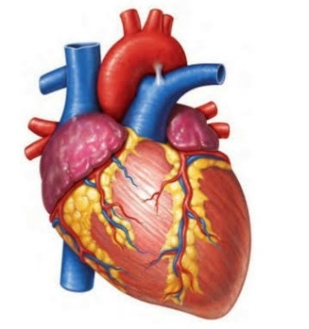  Guide them to identify the different parts of the heart. | 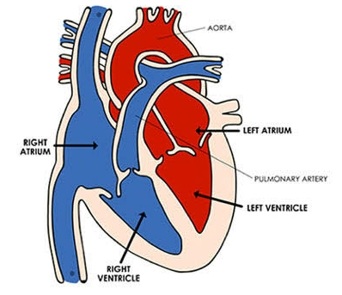 | The Structure of the Heart
Step 4  Development  (10 minutes) | Ask each pupil the group to draw and label the heart.  Describe and choose one or two for presentation. | Groups work. | Groups Evaluation
Step 5  Development  (5 minutes) | Asks each group to present their answers so that you can compare responses with those of other groups.  Call on one or two groups for presentation. | Presentation | Presentation
Step 6  Conclusion  (5 minutes) | To conclude the lesson, the teacher revises the entire lesson and ask the key questions.  THE HEART  The human heart is an organ that pumps blood to all the parts of the body.  The blood cells supplied the vital materials like oxygen and nutrients to the tissues and removing carbon dioxide and other wastes. | The learners listen, ask and answer questions.  STRUCTURE OF THE HEART  The human heart has four chambers: two upper chambers (the atria) and two lower ones (the ventricles).  The right atrium and right ventricle together make up the "right heart," and the left atrium and left ventricle make up the "left heart."  A wall of muscle called the septum separates the two sides of the heart. | Lesson Conclusion

The Structure of the Heart
