LESSON DEVELOPMENT THREE

MEASURING THE VOLUME OF IRREGULAR SOLID

STAGE/TIME | TEACHER’S ACTIVITIES | LEARNER'S ACTIVITIES – MIND/HANDS ON | LEARNING POINTS
Step 1  Introduction  (5 minutes) | Ask pupils to identify and describe the solid object.  Teacher’s remark – To measure the volume of irregular solids, we need water, cylinder, marker and measuring tape (if the cylinder is not calibrated). | Irregular solid object.  Listen to the teacher’s remark and lesson’s introduction – Volume of irregular solids. | Linking the Previous knowledge to the new lesson
Step 2  Development  (5 minutes)  Grouping | 1. Groups the learners into four groups – A, B, C, and D.  2. Guide the learners to choose a leader and secretary for your group.  3. Gives each group learning materials – water, cylinder, marker and measuring tape (if the cylinder is not calibrated). | 1. Belong to a group.  2. Choose their leader and secretary.  3. Received learning materials for their group. | Learner’s group, leader and secretary confirmed.
Step 3  Development  (15 minutes) | Guide the groups to follow the following instructions –  1. Fill the cylinder with water to a certain level.  2. Mark the water level on the cylinder with marker and called it Volume 1.  3. Drop the object into the water and see if it absorbs water.  4. Make a second mark where the new water level is and called it Volume 2. | 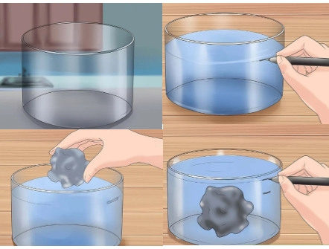  Follow the teacher’s guidelines to perform the following activities. | Activities on irregular solid
Step 4  Development  (5 minutes) | Ask pupils to find the different between Volume 1 and Volume 2. That’s V = V2 - V1 in cm^3. | Groups work | Groups Evaluation
Step 5  Development  (5 minutes) | Asks each group to present their answers so that you can compare responses with those of other groups.  Call on one or two groups for presentation. | Presentation | Presentation
Step 6  Conclusion  (5 minutes) | To conclude the lesson, the teacher revises the entire lesson and ask the key questions. | The learners listen, ask and answer questions. | Lesson Conclusion

