LESSON DEVELOPMENT TWO

RECYCLING WASTE MATERIALS AND THEIR USES

STAGE/TIME | TEACHER’S ACTIVITIES | LEARNER'S ACTIVITIES – MIND/HANDS ON | LEARNING POINTS
Step 1  Introduction  (5 minutes) | Present am empty box (carton) and ask pupils what are the uses of this carton.  Teacher’s remark – Empty carton is one of the recycling waste materials and can be used for things. We will be learning about recycling waste materials and their uses in today’s lesson. | It is used for packaging other goods or materials other than initial content(s).  It is used for design, planning and decoration.  It can be resell.  Listen to the teacher’s remark and lesson’s introduction – Recycling Waste Materials and Their Uses. | Linking the Previous knowledge to the new lesson
Step 2  Development  (5 minutes)  Grouping | 1. Groups the learners into four groups – A, B, C, and D.  2. Guide the learners to choose a leader and secretary for your group.  3. Gives each group learning materials – Any available recycling waste materials and products. | 1. Belong to a group.  2. Choose their leader and secretary.  3. Received learning materials for their group. | Learner’s group, leader and secretary confirmed.
Step 3  Development  (5 minutes) | Ask pupils to identify the recycling waste materials used for making the following recycling products. | 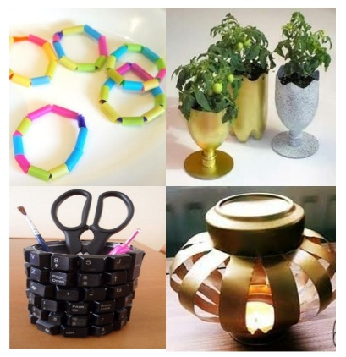  Straws, plastic bottle, can and computer keyboard. | Recycling waste materials and products.
Step 4  Development  (10 minutes) | Ask pupils to state ten (10) recycling waste materials and their uses. | Groups work | Groups Evaluation
Step 5  Development  (10 minutes) | Asks each group to present their answers so that you can compare responses with those of other groups.  Call on one or two groups for presentation.  Take their points and write them on the board. | Presentation | Presentation
Step 6  Conclusion  (5 minutes) | To conclude the lesson, the teacher revises the entire lesson and ask the key questions. | The learners listen, ask and answer questions. | Lesson Conclusion

