LESSON DEVELOPMENT ONE

UNITS OF TIME

STAGE/TIME | TEACHER’S ACTIVITIES | LEARNER'S ACTIVITIES – MIND/HANDS ON | LEARNING POINTS
Step 1  Introduction  (5 minutes) | Get a sample of clock (wristwatch) and ask the pupils to identify it.  Ask them the uses of clock.  Teacher’s remark – Good, clock is used for checking (measuring time). Today, we are going to learn about Time and its Units | 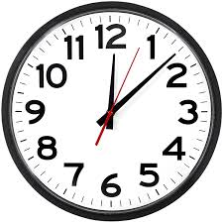  Clock (wristwatch)  It is used for checking (measuring) time.  Listen to the teacher’s remark and lesson’s introduction – Units of Time | Linking the Previous knowledge to the new lesson
Step 2  Development  (5 minutes)  Grouping | 1. Groups the learners into four groups – A, B, C, and D.  2. Guide the learners to choose a leader and secretary for your group.  3. Gives each group learning materials – Clock or Wristwatch | 1. Belong to a group.  2. Choose their leader and secretary.  3. Received learning materials for their group. | Learner’s group, leader and secretary confirmed.
Step 3  Development  (5 minutes) | Ask the pupils to identify part of the clock. | The numbers (1 to 12).  Markings (thick and thin)  Second hand  Minute hand  Hour hand | Features of the Clock
Step 4  Development  (10 minutes) | Ask the groups to state what the numbers and markings (thick and thin) present.  Ask them to state the used of second, minute and hour hands are used for. | Groups work | Groups Evaluation
Step 5  Development  (10 minutes) | Asks each group to present their answers so that you can compare responses with those of other groups.  Call on one or two groups for presentation. | Presentation | Presentation
Step 6  Conclusion  (5 minutes) | To conclude the lesson, the teacher revises the entire lesson and ask the key questions. | The learners listen, ask and answer questions. | Lesson Conclusion

