CIVIC EDUCATION FIRST TERM THIRD WEEK BASIC 6
TOPIC: Valuing Nigerian Goods
Value is the extent to which a good or service is perceived by its customer to meet his or her needs or wants, measured by customer's willingness to pay for it. It commonly depends more on the customer's perception of the worth of the product than on its intrinsic Value.
PERFORMANCE OBJECTIVES
- By the end of the lesson, the pupils should have attained the following objectives (cognitive, affective and psychomotor) and be able to identify reasons why we should value Nigerian goods.
ENTRY BEHAVIOR
- The pupils are required to already have learned to buy and sell.
INSTRUCTIONAL MATERIALS
- The teacher will teach the lesson with the aid of Samples of Nigerian goods.
METHOD OF TEACHING
- Explanatory
- Discussion
- Questioning and answering
REFERENCE MATERIALS
- Scheme of Work
- 9 - Basic Education Curriculum
- Course book
- All Relevant Materials
- Online information
CONTENT OF THE LESSON
VALUING NIGERIAN GOODS
Nigerian goods are goods Made in Nigeria. We must give value to made in Nigeria goods and services. We must encourage their usage, by buying them and promoting their use.
GOODS MADE IN NIGERIA
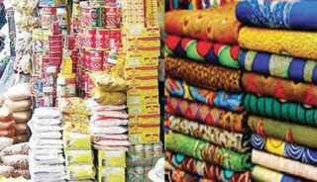
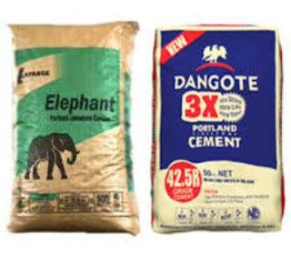
BENEFITS OF VALUING NIGERIAN GOODS
- Valuing Nigerian made goods brings:
- National pride, contentment, hard work, better life, employment;
- Increase in growth and development;
- Increase our domestic production and encourage the consumption of them.
- Bridge the gap between the rich and the poor.
- Conservation of Nigeria’s foreign reserves,
- Value creation for Nigeria’s economy,
- Boost technology transfer/development.
PRESENTATION
- To deliver the lesson, the teacher adopts the following steps:
- To introduce the lesson, the teacher revises the previous lesson. Based on this, he/she asks the pupils some questions;
- Guides pupils in discussion;
- Pupil’s Activities - List Nigerian goods they like and which can be sold to others.
CONCLUSION
To conclude the lesson for the week, the teacher revises the entire lesson and links it to the following week’s lesson.
LESSON EVALUATION
Pupils to: give two reasons why Nigerian goods are to be preferred and their uses.

