ISLAMIC RELIGIOUS STUDIES FIRST TERM WEEK 3 BASIC 6
TOPIC: Al-Qur’an 24 – Recitation of Aayat’ verse 27 and 28
In the name of Allah, the Most Gracious and the Most Merciful.
PERFORMANCE OBJECTIVES
- By the end of the lesson, the pupils should have attained the following objectives (cognitive, affective and psychomotor) and be able to:
- recite ayaat of the Glorious Qu'ran;
- identify the words and ayaat of the Qu'ran;
- Translation. [click]
ENTRY BEHAVIOR
- The pupils are required to already have learned to read Quran.
INSTRUCTIONAL MATERIALS
- The teacher will teach the lesson with the aid of:
- Chart/flash card containing the verses;
- Recorded cassette containing the relevant verses.
METHOD OF TEACHING
- Explanation
- Translation
- Questions and answers
REFERENCE MATERIALS
- Scheme of Work
- 9 - Years Basic Education Curriculum
- Rope of Allah Book 6
- All Relevant Materials
- Internet Information [click]
CONTENT OF THE LESSON
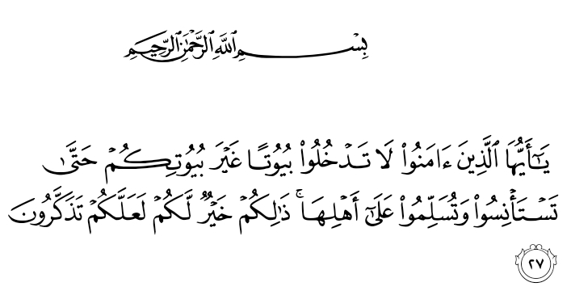

24:27, O you who have believed, do not enter houses other than your own houses until you ascertain welcome and greet their inhabitants. That is best for you; perhaps you will be reminded.
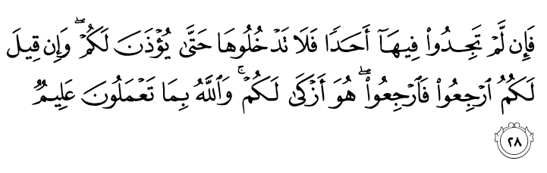

24:28, And if you do not find anyone therein, do not enter them until permission has been given you. And if it is said to you, "Go back," then go back; it is purer for you. And Allah is Knowing of what you do. [click]
PRESENTATION
- To deliver the lesson, the teacher adopts the following steps:
- To introduce the lesson, the teacher revises the previous lesson. Based on this, he/she asks the pupils some questions;
- shows flash cards containing the ayaat;
- identifies the ayaat one after another;
- Pupil’s Activities - Recite the ayaat individually and in group.
- drills the pupils in the pronunciation of the words and translations;
- Pupil’s Activities - Listen attentively to the teacher while reciting, pronouncing and translating.
- correct the pupils mistakes;
- leads the pupils in attempt to write the ayaat;
- Pupil’s Activities - Copy the verses of the Quran and its translations. [click]
CONCLUSION
- To conclude the lesson for the week, the teacher revises the entire lesson and links it to the following week’s lesson. [click]
LESSON EVALUATION
- Pupils to:
- recite the verses of Glorious Qu'ran correctly;
- identify the word and ayaat of the Glorious Qu'ran;
- Translate.

