CIVIC EDUCATION FIRST TERM THIRD WEEK BASIC 4
THEME: CITIZENSHIP
TOPIC: Community Leadership
Community leader is someone who represents the interests of the person in the community. He plays the role of protecting his people.
PERFORMANCE OBJECTIVES
By the end of the lesson, the pupils should have attained the following objectives (cognitive, affective and psychomotor) and be able to:
- explain the concept of traditional rulers or traditional leadership;
- list the duties of a traditional ruler.
ENTRY BEHAVIOR
The pupils are required to already have learned about chieftain title.
INSTRUCTIONAL MATERIALS
The teacher will teach the lesson with the aid of:
- Pupil’s textbooks
- Charts and pictures of traditional rulers
- Resources person
- Other traditional objects, etc.
- Newspaper cuttings
- Video clips
METHOD OF TEACHING
- Explanatory
- Discussion
- Questioning and answering
REFERENCE MATERIALS
- Explanatory
- Discussion
- Demonstration
- Questions and answers
CONTENT OF THE LESSON
TRADITIONAL LEADERSHIP
This is the heads of community like a village, town or city. For examples - Oba, Emir or Eze.
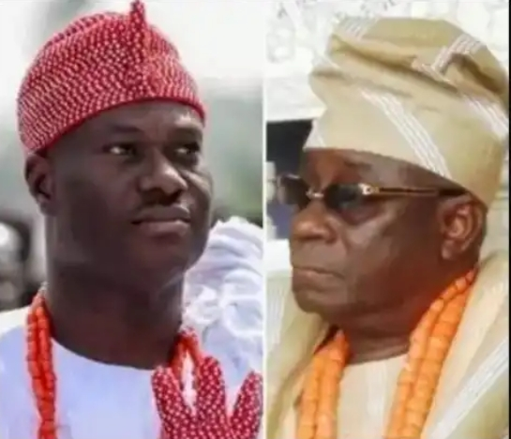
DUTIES OF TRADITIONAL RULER
- Maintaining traditional laws and customs of the people.
- Organizing community in self - help projects and festivals.
PRESENTATION
To deliver the lesson, the teacher adopts the following steps:
- To introduce the lesson, the teacher revises the previous lesson. Based on this, he/she asks the pupils some questions;
- Asks pupils to name traditional leaders in their locality;
- Pupil’s Activities - Make a list of traditional rulers in their locality.
- Asks community leaders in the locality to give a talk on duties of the traditional ruler;
- Leads pupils to form notes on the duties of traditional rulers based on the talk;
- Pupil’s Activities - Form notes on the duties of traditional rulers in response to the talk and questions drawn from it.
CONCLUSION
- To conclude the lesson for the week, the teacher revises the entire lesson and links it to the following week’s lesson.
LESSON EVALUATION/ASSIGNMENTS
- Pupils to -
- write two names of traditional leaders in their community;
- explain the concept of traditional rulers;
- list three duties of traditional ruler;
- give three reasons why traditional leadership is important;

