LESSON DEVELOPMENT THREE

PERIMETER OF COMPOUND SHAPES

STAGE/TIME | TEACHER’S ACTIVITIES | LEARNER'S ACTIVITIES – MIND/HANDS ON | LEARNING POINTS
Step 1  Introduction  (5 minutes) | Find the perimeter of the following rectangles whose dimensions are given below:  - Length 18 cm and breath 11 cm.  - Length 7 cm and breath 19 cm. | - P = 2(L + B) = 2 (18 + 11) cm  P = 2(39) cm  P = 2 x 29 cm  P = 58 cm.  - P = 2(7 + 19) cm  P = 2 (26) cm  P = 2 x 26 cm  P = 52 cm | Previous knowledge and lesson
Step 2  Development  (5 minutes) | - Groups the pupils into four groups – A, B, C, and D.  - Guide the pupils to choose a leader and secretary for your group.  - Gives each group learning materials. Box. | - Belong to a group.  - Choose their leader and secretary.  - Received learning materials for their group. | Pupil’s group, leader and secretary confirmed.
Step 3  Development  (10 minutes) | - Guides the pupils to identify diagram on the chart and the sample of the diagram.  - Leads pupils to cut out the net of the box.  - Guides the pupils to count the faces of the net.  - Leads pupils to measure each line and add altogether. | - Box  - 6 faces  - 14 lines  - P = (10 + 5 + 5 + 6 + 5 + 5 + 6 + 10 + 6 + 5 + 5 + 6 + 5 + 5) cm = 84 cm | Compound shape
Step 4  Development  (10 minutes) | 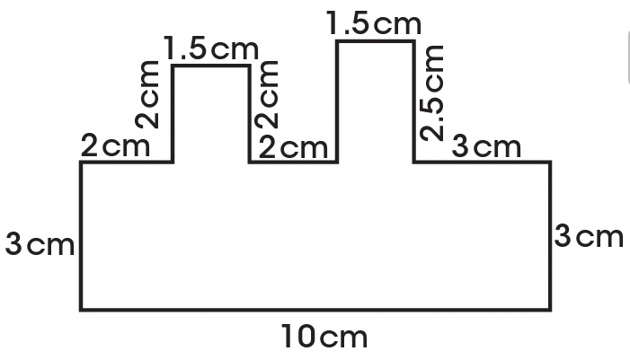  Guides the pupils to find the perimeter of | Working  Perimeter = (10 + 3 + 2 + 2 + 1.5 + 2 + 2 + 2.5 + 1.5 + 2.5 + 3 + 3) cm = 35 cm | Evaluation
Step 5  (10 minutes) | ASSIGNMENT  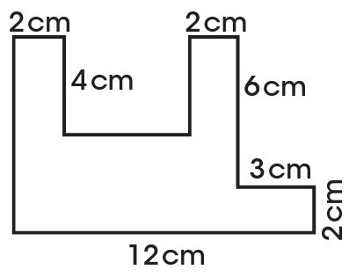  find the perimeter of  CONCLUSION  To conclude the lesson for the week, the teacher revises (through questions and answers) the entire lesson and links it to the next lesson. | Assignment taken.  Listen, ask and answer questions. | Assignment and Conclusion

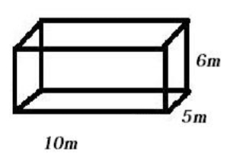
LEARNING/INSTRUCTIONAL MATERIALS
