LESSON DEVELOPMENT ONE

TIME

STAGE/TIME | TEACHER’S ACTIVITIES | LEARNER'S ACTIVITIES – MIND/HANDS ON | LEARNING POINTS
Step 1  Introduction  (5 minutes) | Guides pupils to recite the Units of Time -  60 seconds = 1 minutes  60 minutes = 1 hour  24 hours = 1 hour….  Asks them – what is the time for assembly, break time and closing time for junior and senior? | MIND ON ACTIVITIES  Pupils recite units of time.  Assembly is 7 45 am.  Break time is 11 45 am.  Closing is 1 00 pm and 2 00 pm for junior and senior respectively. | Linking the Previous knowledge to the new lesson
Step 2  Development  (5 minutes)  Grouping | 1. Groups the learners into four groups – A, B, C, and D.  2. Guide the learners to choose a leader and secretary for your group.  3. Gives each group learning materials. – chart of units of time, clock, stop watch. | 1. Belong to a group.  2. Choose their leader and secretary.  3. Received learning materials for their group. | Learner’s group, leader and secretary confirmed.
Step 3  Development  (5 minutes) | Ask the pupils – how many days are in February and March, 2019?  Lets them know that September, April, June and November have 30 days. All the rest have 30 days except for February with 28 days (29 day leap year) | MIND ON ACTIVITIES  February 28 days and March 31 days. The | Number of days in a month.
Step 4  Development  (5 minutes) | Guides pupils to use a.m. as the time from midnight to midday while p.m. as the time from midday to midnight. That’s,  A.m. – morning  P.m. – evening | MIND ON ACTIVITIES  Pupils understand the time from midnight to midday as a.m. and time from midday to midnight as p.m. | A.m. and p.m.
Step 5  Development  (15 minutes) | Guides and asks –  1. What is quarter to/after and half an hour?  2. What is quarter to 5?  3. What is quarter after 5?  4. What is half past 8?  5. Set the clock to quarter to/after 5? | HANDS ON ACTIVITIES  1. Quarter to/after means 15 minutes to or after while half an hour means 30 minutes.  2. Quarter to 5 = 5h 00m – 15 = 4h 45m.  3. Quarter after 5 = 5h 00m + 0h 15m = 5h 15m.  4. Half past 8 = 8h 00m + 0h 30m = 8h 30m.  5.  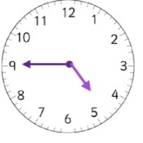  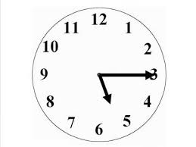 | Working Examples
Step 6  Conclusion  (5 minutes) | To conclude 4the lesson, the teacher revises the entire lesson and ask the key questions.  Keys questions – Assignment  1. Mohammed starts from home at 7:15 a.m. and arrives at school at 8:05 a.m. How long does he take to get to school?  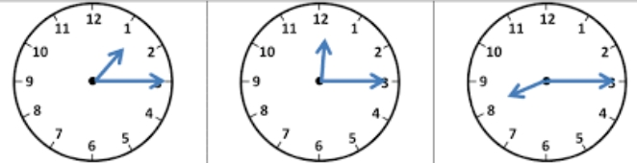  2. Tell the time in quarter – | Pupils listen, ask and answer questions.  Assignment taken. | Conclusion and assignment

