LESSON DEVELOPMENT ONE

MEANING OF FORCE – PUSH AND PULL

STAGE/TIME | TEACHER’S ACTIVITIES | LEARNER'S ACTIVITIES – MIND/HANDS ON | LEARNING POINTS
Step 1  Introduction  (5 minutes) | INTRODUCTORY ACTIVITIES  Asks pupils to describe the following pictures. | 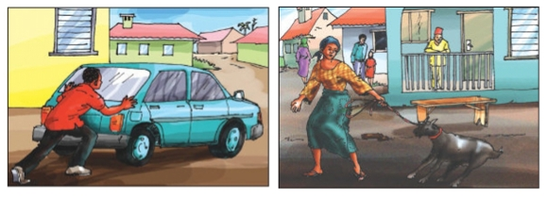  MIND/HANDS ON ACTIVITIES | Linking the Previous knowledge to the new lesson
Step 2  Development  (5 minutes)  Grouping | 1. Groups the learners into four groups – A, B, C, and D.  2. Guide the learners to choose a leader and secretary for your group.  3. Gives each group learning materials – strong rope, ball, wood, classroom door, nails and hammer. | 1. Belong to a group.  2. Choose their leader and secretary.  3. Received learning materials for their group. | Learner’s group, leader and secretary confirmed.
Step 3  Development  (5 minutes) | Takes all groups to the field for this activity on the chart. | 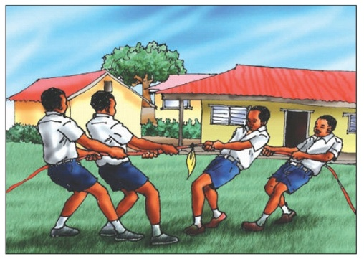 | Exercising Force
Step 4  Development  (5 minutes) | Divides the 4 groups into 2 two groups.  Asks to choose 2 members to represent them in their group.  The first group will be outside the class and the second group inside the class.  Closes the door and asks each first representatives to open the door while the other second prevent the door from opening. | 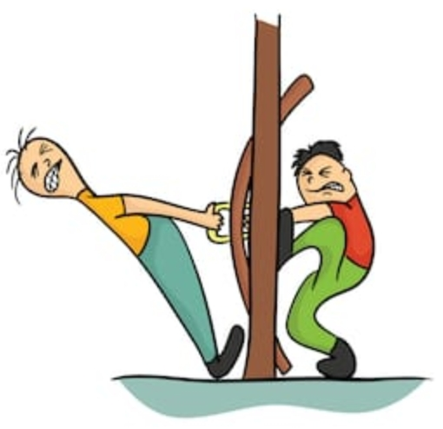 | Force – push and pull
Step 5  Development  (5 minutes) | Asks the groups –  To describe both activities in step 3 and step 4. | Groups Activities | Groups work
Step 6  Development  (10 minutes) | Asks each group to present their answers so that you can compare responses with those of other groups. | Presentation | Presentation
Step 7  Conclusion  (5 minutes) | To conclude the lesson, the teacher revises the entire lesson and ask the key questions.  SUMMARY –  Force is a push or pull on an object. A force can cause an object to start moving, slow down, stop moving, change shape or direction.  When you pull or push something, you are using an effort to try to make it move.  KEY QUESTIONS – Different between push and pull force. | The learners listen, ask and answer questions.  Push is to move something away from you (it does not move towards you).  Also, when you pull something, it may move towards you) it does not move away from you). | Lesson Evaluation and Conclusion

