LESSON DEVELOPMENT TWO

TYPES OF PULLEYS

STAGE/TIME | TEACHER’S ACTIVITIES | LEARNER'S ACTIVITIES – MIND/HANDS ON | LEARNING POINTS
Step 1  Introduction  (5 minutes) | 1. What is pulley?  2. Give 4 examples of a pulley. | 1. A pulley is a simple machine that is used to lift heavy objects.  2 Examples of pulleys are grinding machine, sowing machine, a crane, etc. | Linking the Previous knowledge to the new lesson
Step 2  Development  (5 minutes)  Grouping | 1. Groups the learners into four groups – A, B, C, and D.  2. Guide the learners to choose a leader and secretary for your group.  3. Gives each group learning materials. – chart showing different types of pulleys. | 1. Belong to a group.  2. Choose their leader and secretary.  3. Received learning materials for their group. | Learner’s group, leader and secretary confirmed.
Step 3  Development  (10 minutes) | 1. How many pulleys are there on the chart?  2. Guides and lets pupils study and describe each of the pulley. | 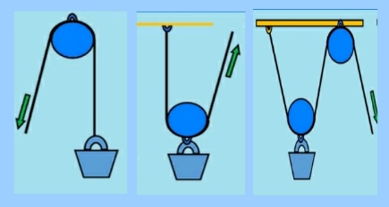 | MIND ON ACTIVITIES
Step 4  Development  (10 minutes) | Asks each group to present their answers so that you can compare responses with those of other groups. | Presentation
Step 5  Conclusion  (10 minutes) | To conclude the lesson, the teacher revises the entire lesson and ask the key questions.  KEY QUESTIONS  1. Describe a pulley.  2. State and describe the types of pulleys.  SUMMARY –  TYPES OF PULLEYS  Fixed pulley is a pulley fixed to a point. Look at the chart, we will see fixed pulley is fixed.  Movable pulley is free to move up and down on the rope.  Compound pulley is a combination of fixed and movable pulleys. | The learners listen, ask and answer questions.  PULLEYS  A pulley consists of a rope and wheel mounted with axle.  There are three main types of pulleys: fixed, movable, and compound. | Lesson Evaluation and Conclusion

