LESSON DEVELOPMENT TWO

PROPERTIES OF MAGNETS

STAGE/TIME | TEACHER’S ACTIVITIES | LEARNER'S ACTIVITIES – MIND/HANDS ON | LEARNING POINTS
Step 1  Introduction – Introductory Activities  (5 minutes) | Ask pupils – what are the different between magnetic and non magnetic materials? | Magnetic materials are materials that can be attracted by magnet.  While non magnetic materials are materials that cannot be attracted by magnet. | Linking the Previous knowledge to the new lesson
Step 2  Development  (5 minutes)  Grouping | 1. Groups the learners into four groups – A, B, C, and D.  2. Guide the learners to choose a leader and secretary for your group.  3. Gives each group learning materials – magnetic bars. | 1. Belong to a group.  2. Choose their leader and secretary.  3. Received learning materials for their group. | Learner’s group, leader and secretary confirmed.
Step 3  Development – Groups Activities  (5 minutes) | Guides each group identify North and South poles of a magnet. | 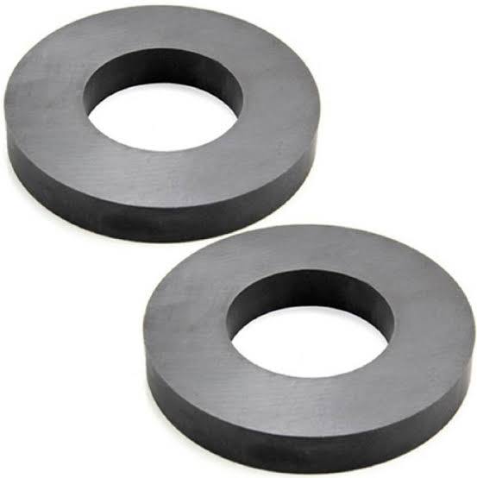 | North and South Poles of a Magnets
Step 4  Development – Groups Activities  (10 minutes) | Guided Instructions –  1. Place North Pole of a magnet on another South pole of a magnet. Record your observation.  2. Place North Pole of a magnet on another North pole of a magnet. Record your observation.  3. Place South Pole of a magnet on another South pole of a magnet. Record your observation. | RECORD OBSERVATIONS  1. The opposite poles of two magnets attract to another.  2. North pole drives North Pole away.  3. South pole drives South Pole away. | Properties of Magnets
Step 5  Development  (10 minutes) | Asks each group to present their results/solutions so that you can compare responses with those in other groups. | Presentation | Group Presentation
Step 6  Conclusion  (10 minutes) | To conclude the lesson, the teacher revises the entire lesson and ask the key questions.  SUMMARY  Properties of Magnets  1. Magnets attract magnets  2. Opposite poles attract one another.  3. Like poles push one another away (repel).  4. Magnets attract objects of iron, cobalt and nickel. | The learners listen, ask and answer questions.  KEY QUESTIONS – what are the properties of Magnets | Lesson Evaluation and Conclusion

Reference book – Primary 6 Basic Science & Technology

