LESSON DEVELOPMENT ONE

COUNTING AND WRITING OF NUMBERS UP TO 500

STAGE/TIME | TEACHER’S ACTIVITIES | LEARNER'S ACTIVITIES – MIND/HANDS ON | LEARNING POINTS
Step 1  Introduction  (5 minutes) | Ask pupils to count the of square on the chart. |  | Linking the Previous knowledge to the new lesson
Step 2  Development  (5 minutes)  Grouping | 1. Groups the learners into four groups – A, B, C, and D.  2. Guide the learners to choose a leader and secretary for your group.  3. Gives each group learning materials – square chart. | 1. Belong to a group.  2. Choose their leader and secretary.  3. Received learning materials for their group. | Learner’s group, leader and secretary confirmed.
Step 3  Development  (10 minutes) | Ask each of the group to number from 1 to 100 on each of the square box. | 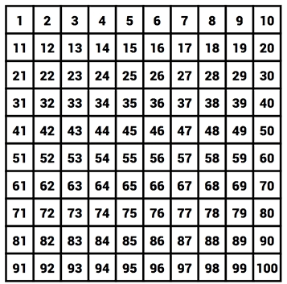 | Writing numbers up to 100
Step 4  Development  (10 minutes) | Ask them to complete the table. | 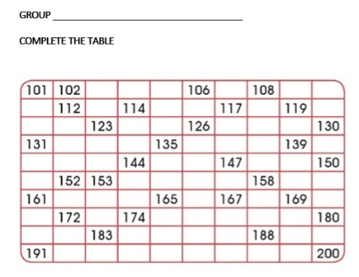 | Writing numbers from 100 to 200
Step 6  Development | Asks each group to present their answers so that you can compare responses with those of other groups. | Presentation | Presentation
Step 7  Conclusion  (10 minutes) | To conclude the lesson, the teacher revises the entire lesson and ask the key questions.  KEY QUESTIONS – ASSIGNMENT  Copy and complete the following –  1. 300, ______, ______, 303, ______, ______, 306.  2. ______, ______, ______, ______, 455.  3. ______, ______, 497, ______, ______, 500. | The learners listen, ask and answer questions. | Lesson Evaluation and Conclusion

